**BIGDATA ANALYSIS WITH IBM CLOUD DATABASES**

**DESCRIPTION :**

Big data analytics is the use of advanced analytic techniques against very large, diverse big data sets that include structured, semi-structured and unstructured data, from different sources, and in different sizes from terabytes to zettabytes.

What is big data exactly? It can be defined as data sets whose size or type is beyond the ability of traditional relational databases to capture, manage and process the data with low latency. Characteristics of big data include high volume, high velocity and high variety. Sources of data are becoming more complex than those for traditional data because they are being driven by artificial intelligence (AI), mobile devices, social media and the Internet of Things (IoT). For example, the different types of data originate from sensors, devices, video/audio, networks, log files, transactional applications, web and social media — much of it generated in real time and at a very large scale.

With big data analytics, you can ultimately fuel better and faster decision-making, modelling and predicting of future outcomes and enhanced business intelligence. As you build your big data solution, consider open source software such as Apache Hadoop, Apache Spark and the entire Hadoop ecosystem as cost-effective, flexible data processing and storage tools designed to handle the volume of data being generated today.

BENEFITS:

**records and Faster, better decision making:**

*Businesses can access a large volume of data and analyze a large variety sources of data to gain new insights and take action. Get started small and scale to handle data from historical in real-time

**Cost reduction and operational efficiency:**

*Flexible data processing and storage tools can help organizations save costs in storing and analyzing large anmounts of data.  Discover patterns and insights that help you identify do business more efficiently.

**Improved data-driven go to market :**

Analyzing data from sensors, devices, video, logs, transactional applications, web and social media empowers an organization to be data-driven.  Gauge customer needs and potential risks and create new products and services.

IBM Cloud Databases for PostgreSQL | IBM

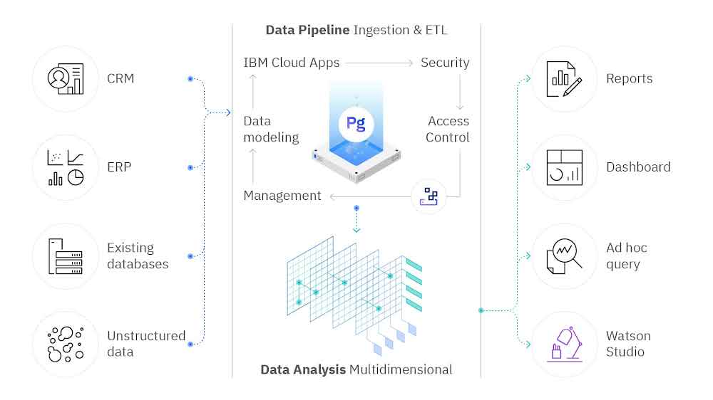

**DESIGN THINKING :**

**1. *Data Selection*:**

- Identify and gather relevant datasets, such as climate data from NOAA or social media trends from platforms like Twitter.

**2. *Database Setup*:**

- Utilize IBM Cloud Databases to create a structured and efficient storage system for the collected datasets.

**3. *Data Exploration*:**

- Develop queries and scripts to explore and clean the datasets, extracting pertinent information and detecting patterns.

**4. *Analysis Techniques*:**

- Apply appropriate analysis techniques, ranging from statistical analysis to machine learning, to uncover valuable insights within the data.

**5. *Visualization*:**

- Design impactful visualizations, using tools like Tableau or Matplotlib, to present the analysis results in an understandable and visually appealing manner.

**6. *Business Insights*:**

- Interpret the analysis findings to derive business intelligence and actionable recommendations that can inform decision-making and strategy.